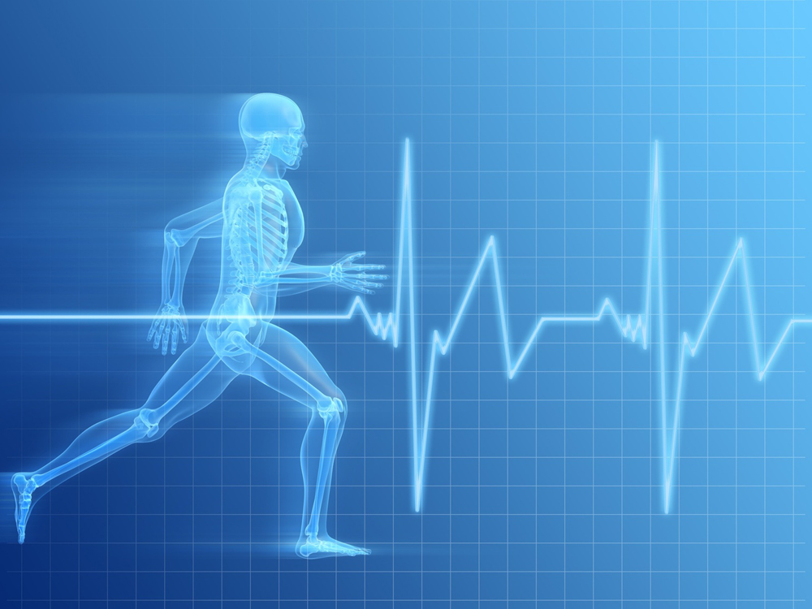
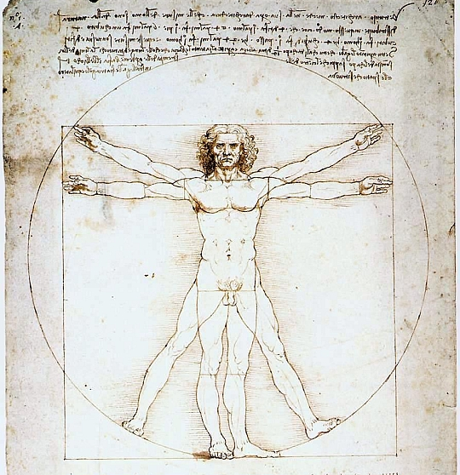
© Junior Cycle PE

MY QUESTIONS
What’s Coming Next
After we have deepened our understanding of Body Systems we focus all of our attention on one body system,

the one that defends our body,

our immune system.
Key Words
- Function
- Structure
- Tissue
- Organ
- Organ System
- Site of Exchange

Our Inquiry into HOW DO WE STAY ALIVE will help us better understand that:

- Cells are the basic building blocks of our body
- Our body systems provide each cell with the materials needed to stay alive AND remove the wastes produced by each cell.
- If one part of a system is missing or damaged, the system will not function well or may not function at all.

Human Body Systems
Science 8 • Biology • http://martensclass.wordpress.com • jmartens@vsb.bc.ca
Science 8
Mr. Martens
Staying Alive
DO
B | D | A | Learning Goal
 |  |  | I can distinguish between cells, tissues, organs, and organ systems based on their structure and function.
 |  |  | I can describe how organ systems work together to provide each & every cell with the materials necessary for them to stay alive.
 |  |  | I can describe how organ systems work together to take the wastes produced by each & every cell and remove them from the body.
 |  |  | I can describe a problem in a system that results when part of the system is missing or broken.
 |  |  | I can describe a problem in the Digestive System that results when part of the digestive system is missing or damaged.
 |  |  | I can describe a problem in the Excretory System that results when part of the excretory system is missing or damaged.
 |  |  | I can describe a problem in the Respiratory System that results when part of the respiratory system is missing or damaged.
 |  |  | I can describe a problem in the Circulatory System that results when part of the circulatory system is missing or damaged.

KNOW
B | D | A | Learning Goal
 |  |  | I can list the main characteristics of any system.
I can describe what biologists mean when they use the word “structure”.
I can describe what biologists mean when they use the word “function”.
Digestive System:
I can identify the main components, the main function, and site of exchange.
Excretory System:
I can identify the main components, the main function, and site of exchange.
Respiratory System:
I can identify the main components, the main function, and site of exchange.
Circulatory System:
I can identify the main components, the main function, and site of exchange.

